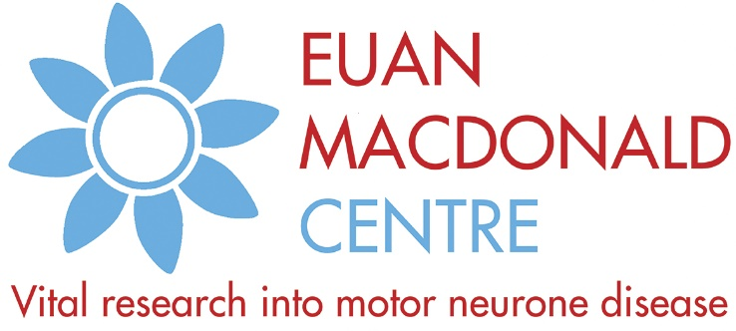

Suggested wording for JustGiving

Motor neurone disease (MND) is a debilitating condition that causes muscle weakness, loss of mobility, difficulty speaking and breathing, and ultimately paralysis.
The condition is life-shortening and there is currently no effective treatment or cure. Researchers at the Euan MacDonald Centre for MND Research are working hard to change this.
The Euan MacDonald Centre unites over 200 doctors, scientists and healthcare professionals at Universities across Scotland.
Working with the NHS and academic scientists around the world, researchers at the Centre are exploring the causes of motor neurone disease, developing new treatments, and improving the quality of life for people living with MND.
[Insert information about your event here]
The money received through this JustGiving page will go directly to the Euan MacDonald Centre. Please donate generously today and help the researchers achieve their goal to slow, stop and eventually reverse the effects of this devastating condition.
Thank you for your support.

